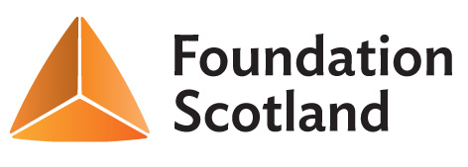
Drone Hill Community Fund – Grantshouse Community Council
Microgrant Application Form

Contact Details:
Name of group or individual applying:
Main contact:
Address:
Post code:
E-mail: Telephone:
About you and / or your organisation:
Are you a constituted group Y / N
Details of Micro Grant Requested:
Please provide details of your project – what activities will you carry out, who are the beneficiaries and what difference will the project make?

How much are you requesting? (up to £250):
What will the micro-grant be used to pay for? (Please provide a cost breakdown). Invoices should be sent to GCC on completion of the project.

Declaration: I certify that the information contained in this application is correct, and that I am authorised to make the application on behalf of the above group / individual.
Name: (Please print):
Signature: Date:
Please send your completed form to Ian Fleming, Renton Gardens Bungalow, Grantshouse, TD11 3RP.

